LAB 4 REPORT

KRISHNA CHAITANYA NALLURI
16157744

First of all i have downloaded the HMMWS web project from black board and i have imported that one into OEPE eclipse and then i have started the Glass fish server.

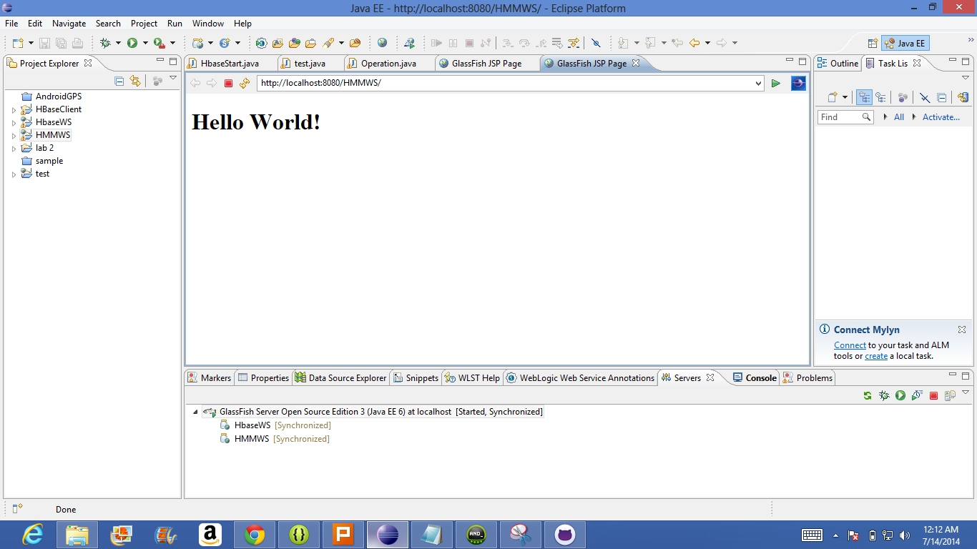

By using the sensor test file that is available in the black board, i have created gestures like Punch, Circle, Slide and Combination . Here i am submitting the text and sequence files with this report.

As per the step 1, i have converted the text file into sequence file for training files.

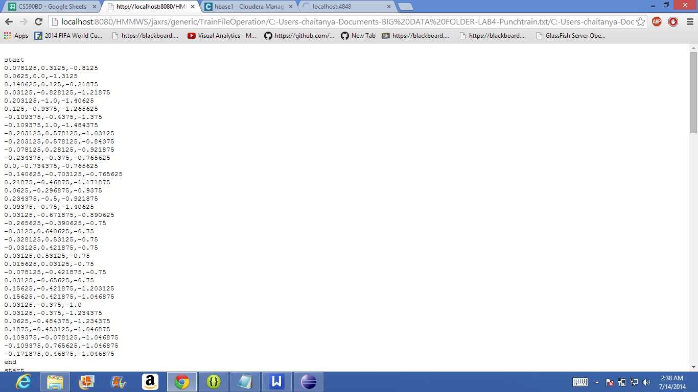

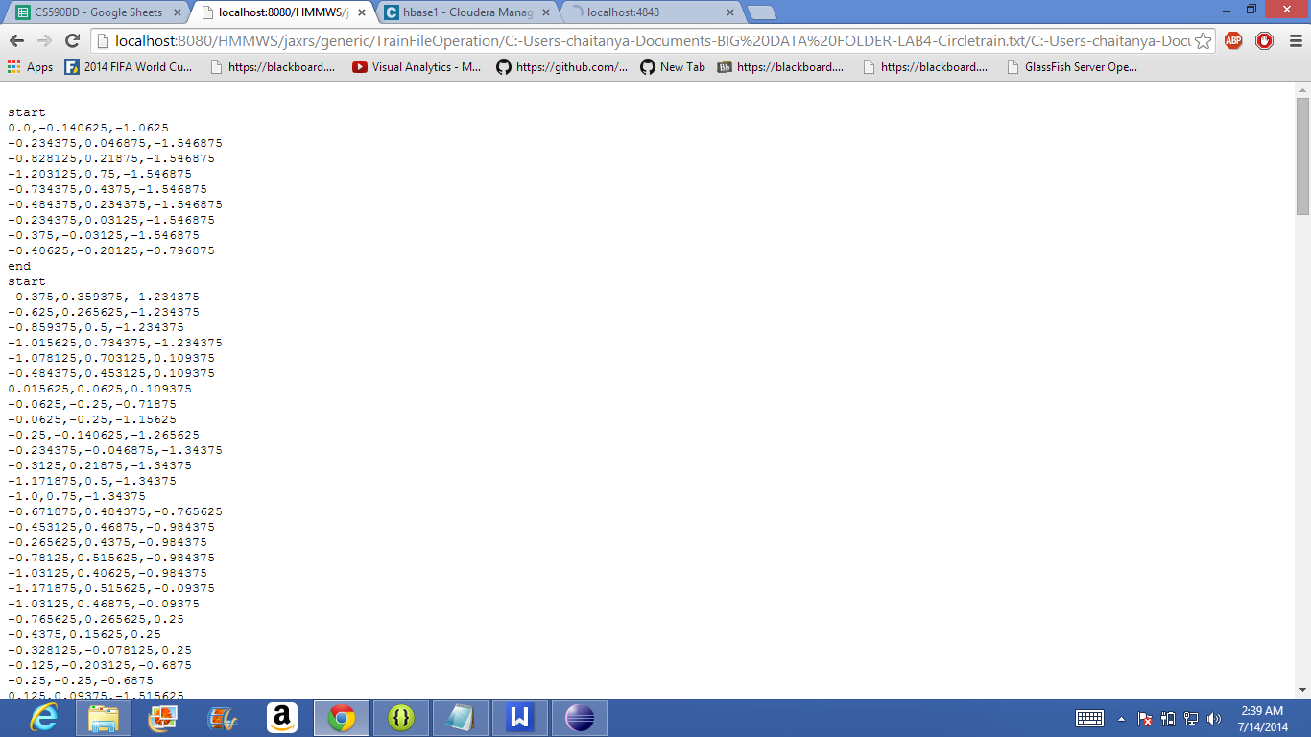

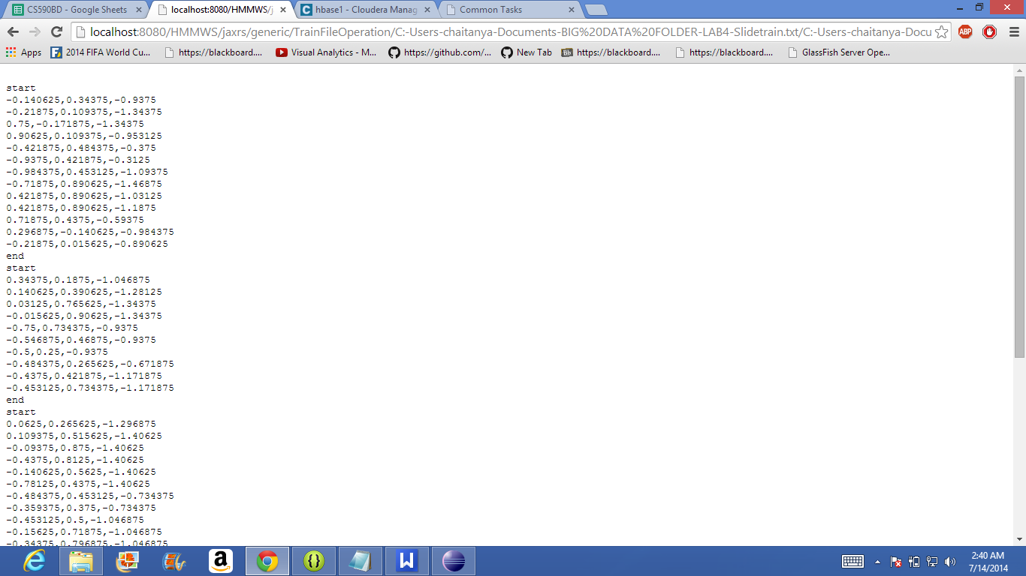

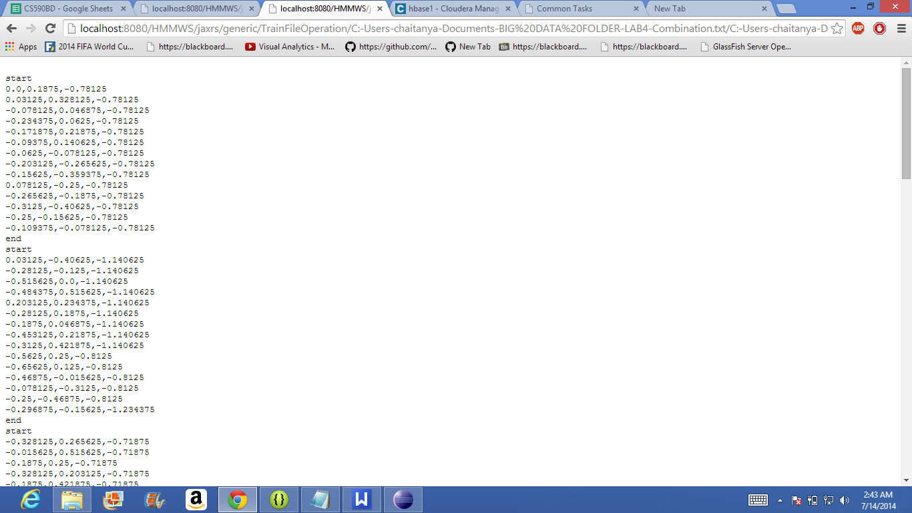

As per the test 2, i have generated sequence files for testing file.
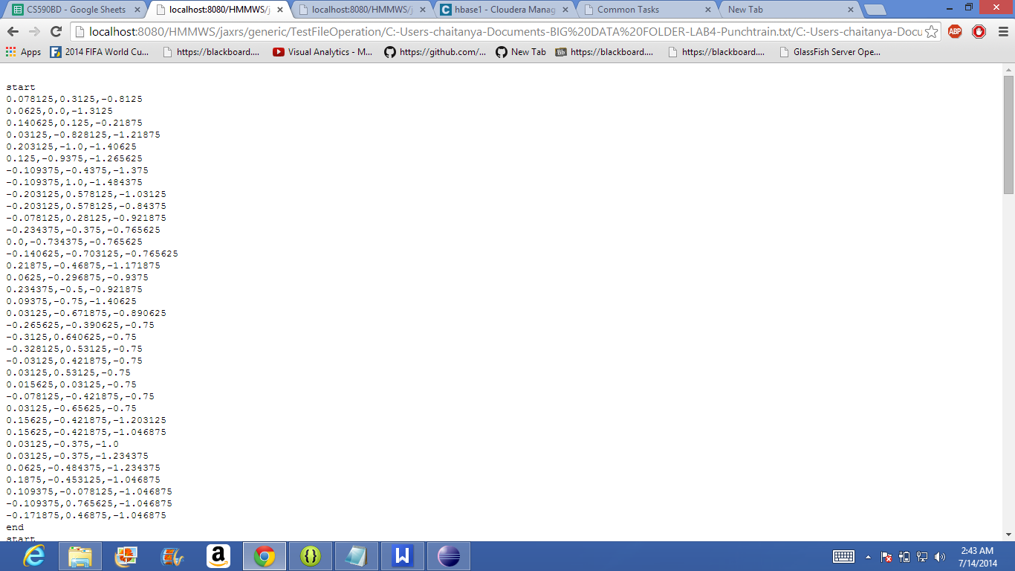

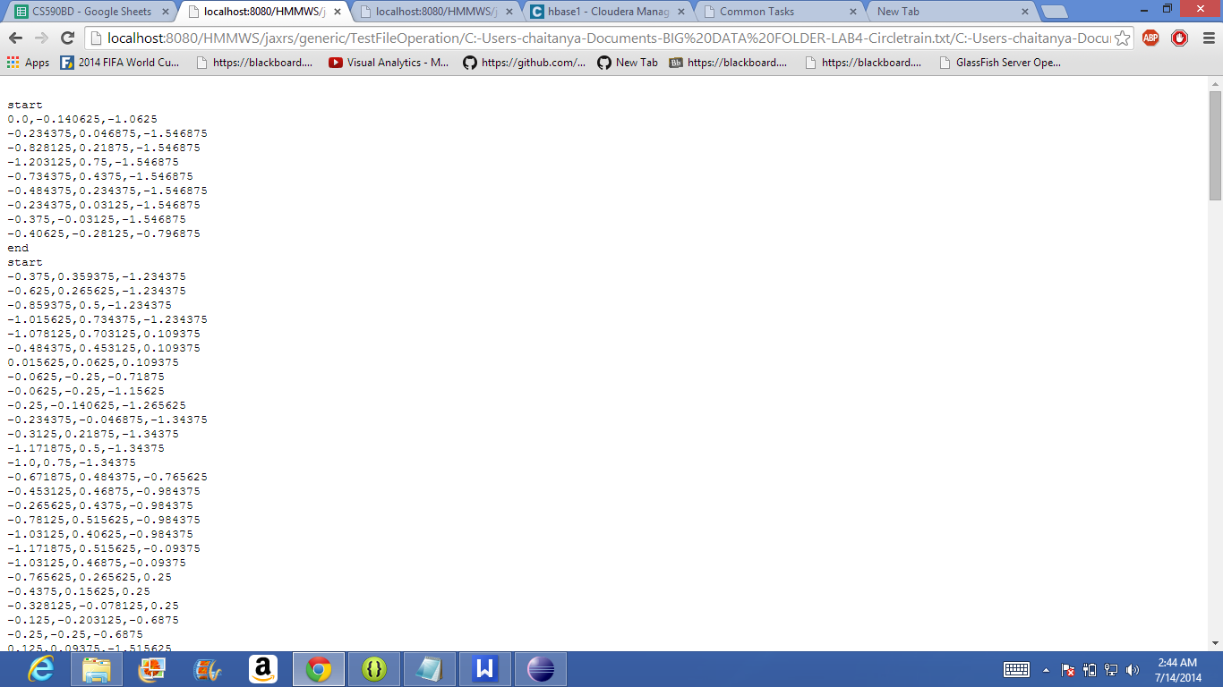

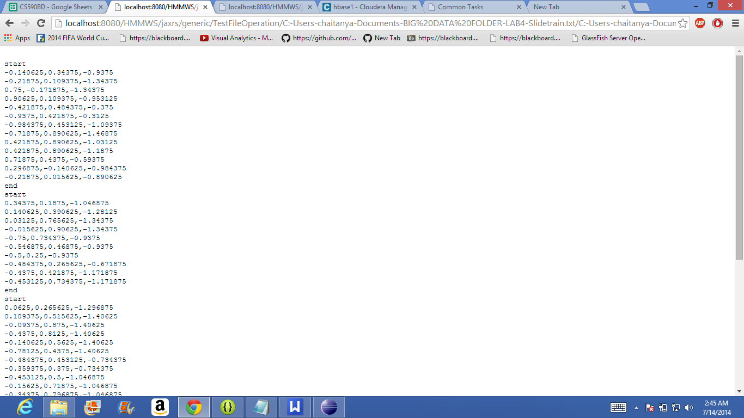
‘
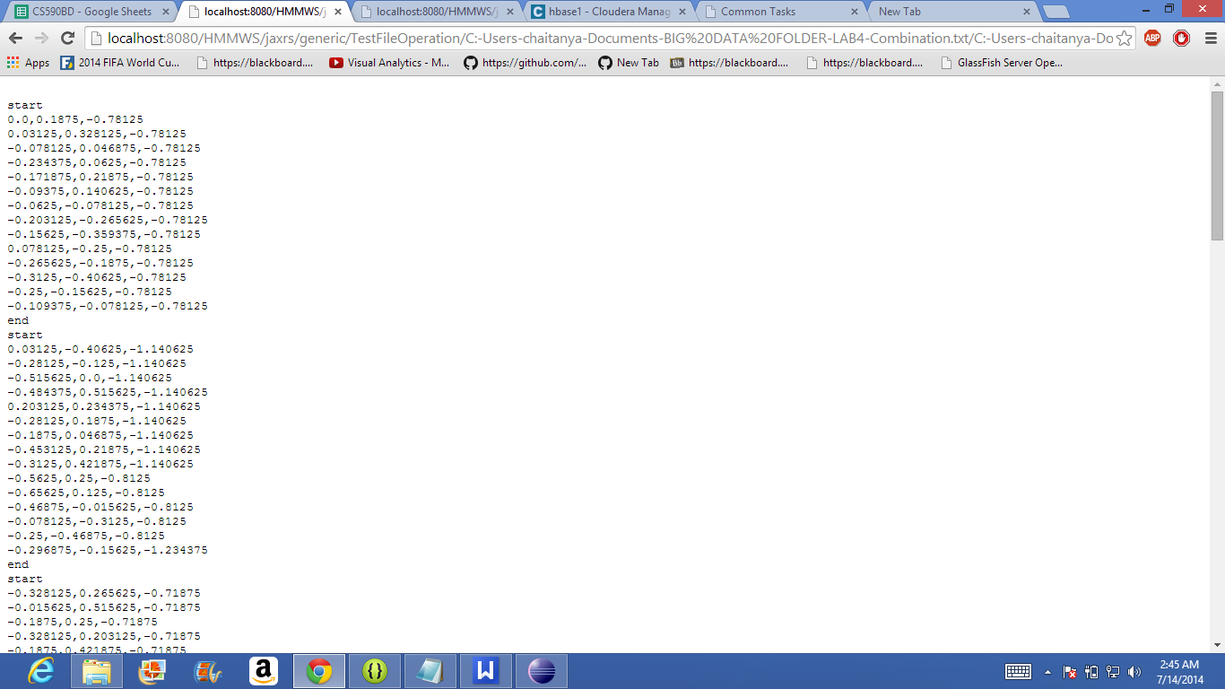

Now as per the step 3, i did for three motions individually.
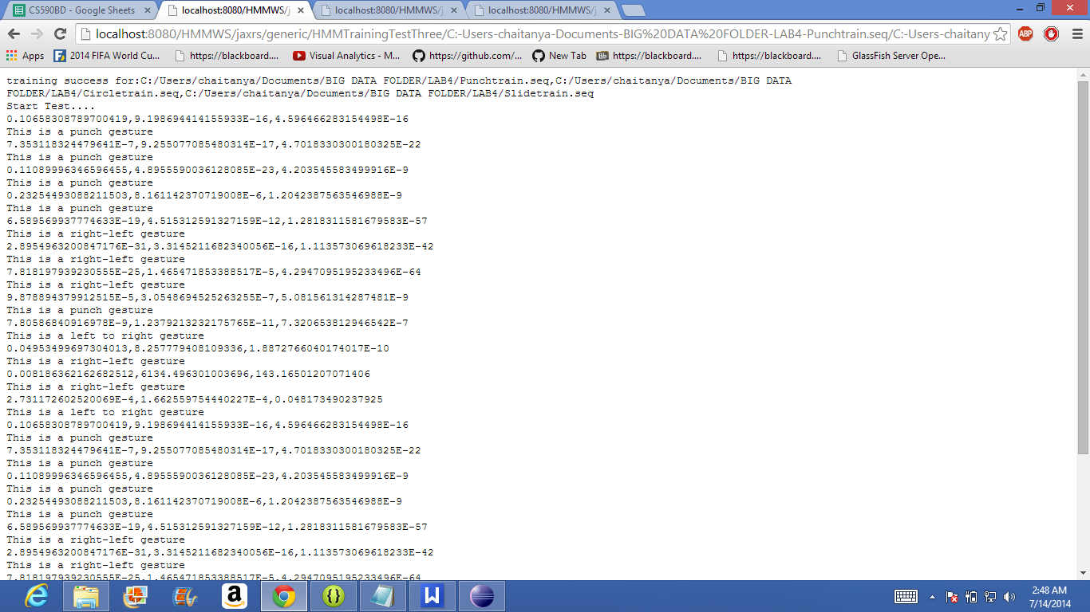

Training and testing for Activity recognition for multiple motions as training data.:

